**BIL 101 INTRODUCTION TO COMPUTER SCIENCE**

**HW #05 ANSWER KEYS**

**Answer 1 and 2:**

|  |  |
| --- | --- |
| **Syntaxes** | **Descriptions of syntaxes(semantics)** |
|  | Screws two pieces to each other horizintally |
|  | Screws two pieces to each other vertically |
|  | combines horisintally the two pieces to each other |
|  | combines vertically the two pieces to each other |
|  | Screw rondumly |

**Answer 3:**

the algorethim of the desk biulding would be like bellow:

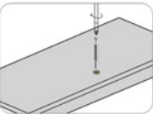

place a needle in the piece of desk

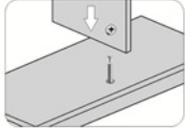

the upper piece to down one.

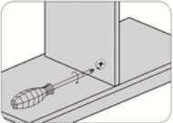

the two of them each other.

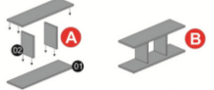

01 & 02 in section **A** then make section **B** from it**.**

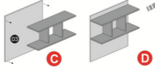

**B** & 03 each other which are containig of section **C** and biuld section **D.**

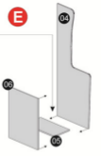

paste the 06 & 05 each other in section **E** and also do the same prosedure beetwen 05 & 04 in section **E.**

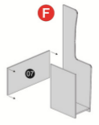

screw and combine the peice 07 & section **E** and make section **F** from them.

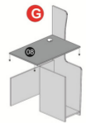

Paste and screw the two pieces 08 & section **F** each other and it will cause to make a new part which will be called section **G**.

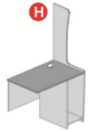

give an other name for section which will be section **H ,**when it’s combinning prosidure has finishid.

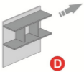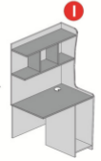

Combine horizintally the section **D** section **I** each other and go to the section **J** .

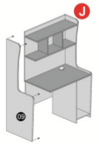

and finnaly paste and combine the 09 part with section **J**

and compelete the desk combinning or desk srewing algorethim .